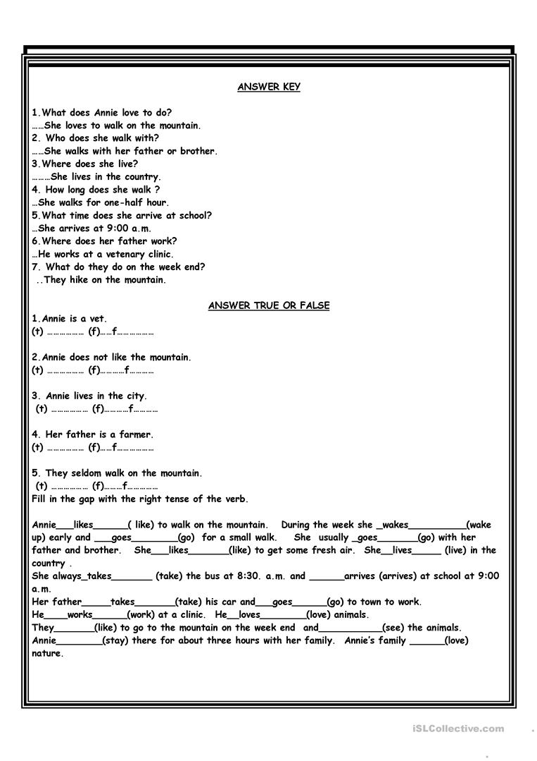

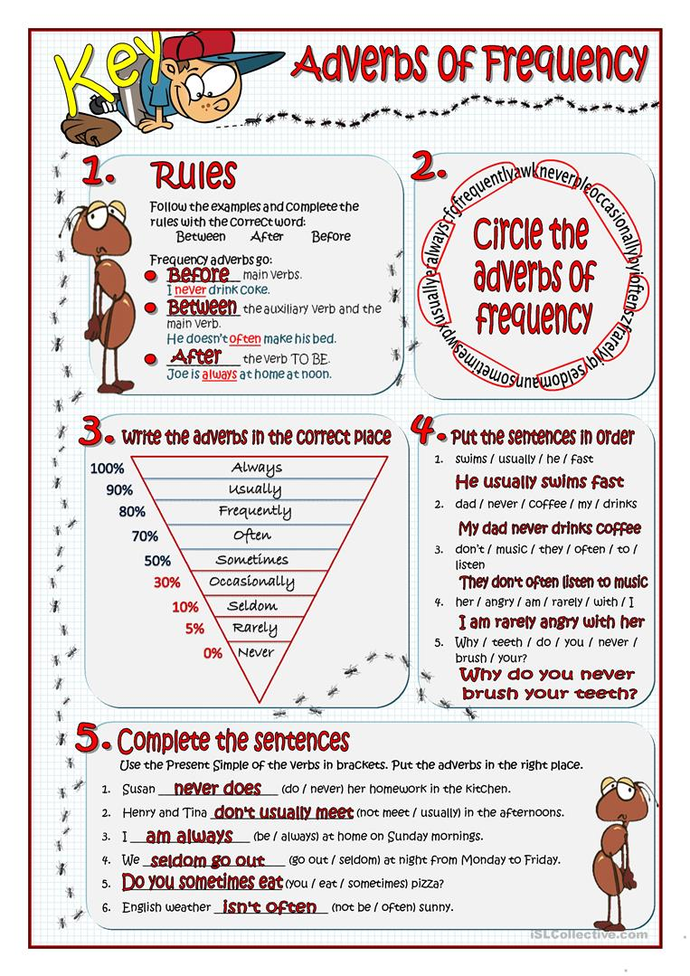

1.Fishing. 2. Doing. 3. teaching. 4. Listening. 5. smoking. 6. Cooking/ painting. 7. Smoking. 8. Working. 9. Getting up.10. Sunbathing. 11. Knitting. 12. Running.