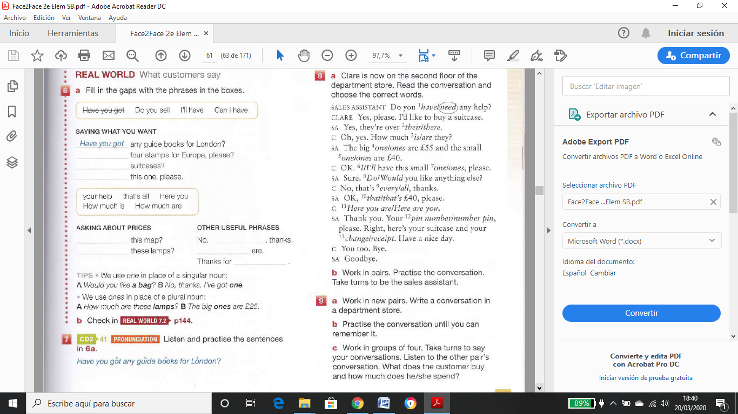

How much is

How much are

Here you

That´s all

Your help

Can I have

Do you sell

I’ll have